3215 Project
SPI Connection using Dragon Boards

Group – 2B
-Pratham Khatri
-Harsh Khandelwal
-Ali Khan
-Jaevana Marryshow
Hardware Setup
Signal Name | Master Pin (Admin) | Slave Pin (Locker) | Description
MOSI | PS5 | PS5 | Master Out, Slave In (Data to Slave)
MISO | PS4 | PS4 | Master In, Slave Out (Data to Master)
SCK | PS6 | PS6 | Serial Clock (Generated by Master)
SS | PS7 | PS7 | Slave Select (Master controls Slave attention)
GND | GND | GND | Common Ground Reference
Master wiring to Slave wiring
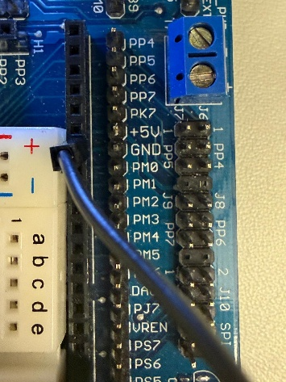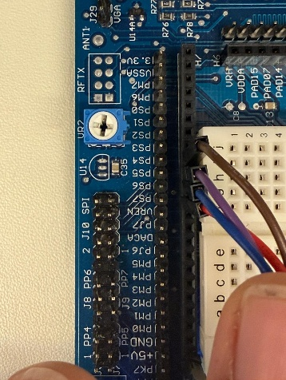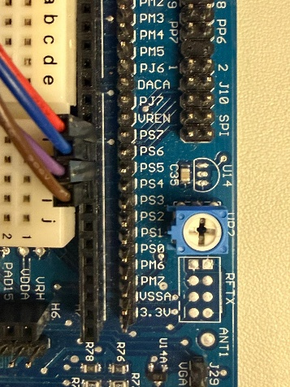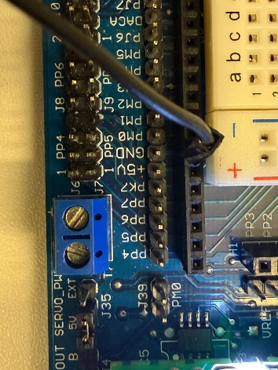
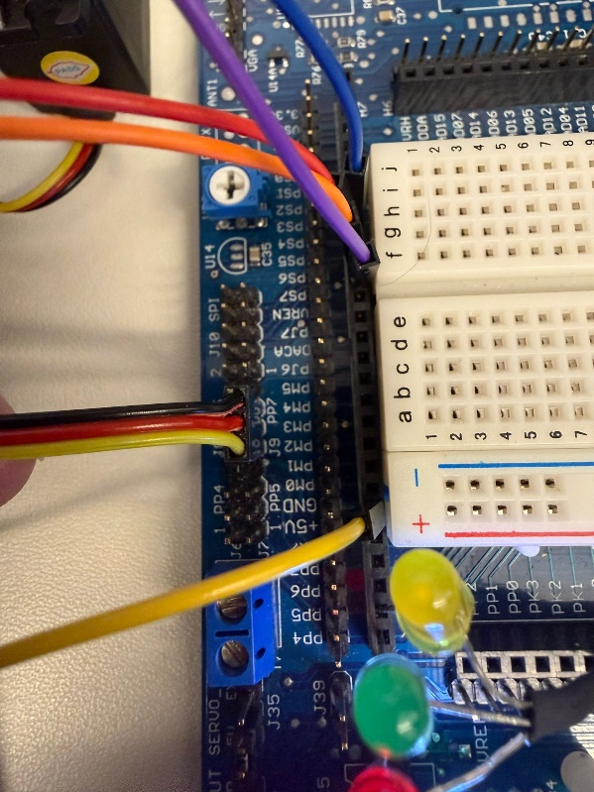 (ignore the wiring of the SPI ports for this.)
The above is the servo motor which is connected to PP7 of the dragon board.
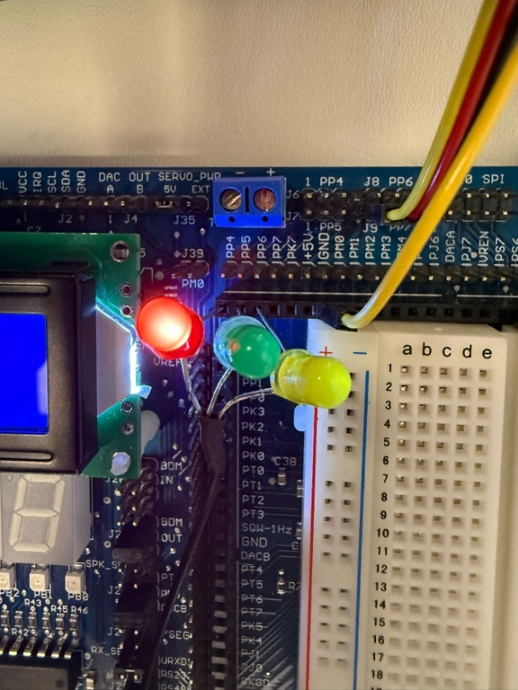
And this is the Led, Red is connected to PP4 and green to PP5. And the common cathode is connected to the Ground
How to Run the code?
- Firstly Open the Codewarrior IDE and make 2 New projects one by one.
- The first Project will be Master program and the second Project will be Slave Program.
- They Both have Different codes hence we will use two different Projects in the IDE.
- Please copy the master and slave code in the main.c respectively.
- Set up the Dragon board(old versions) and connect the power supply and USB to the computer, make sure you know the COM for the master and slave ports on your PC.
- Setup the Hardware wires as mentioned in the Hardware Setup above.
- Now we will run the code for the Slave first.
- Once the slave program is running, you can run the Master Code and disconnect the USB cable from the slave.
- Now the program is running and both our Master and Slave are running together.
1. Project Overview and Objectives
1.1 Abstract
The objective of this project was to architect and implement a distributed embedded security system utilizing the HCS12 microcontroller platform. The system simulates a high-security banking or storage facility where a local access node (the "Locker") is physically separated from the central control node (the "Admin").
Unlike standalone locks, this system requires a two-stage authentication process:
- Remote Authorization: An administrator must approve a request via the Master Node.
- Local Authentication: The user must enter a specific PIN on the Slave Node.
1.2 Deliverables
The project was successful in delivering a fully functional prototype with the following features:
- Full-Duplex Communication: Implementation of the Serial Peripheral Interface (SPI) protocol for synchronized data exchange.
- Distributed Database Architecture: Secure storage of PIN credentials on the local node, with on-demand transmission to the central node.
- Peripheral Integration: Simultaneous control of 4x4 Matrix Keypads, HD44780 LCDs, Multiplexed 7-Segment Displays, and PWM-driven Servo Motors.
- Robust Error Handling: Implementation of timeout logic and invalid-PIN rejection states.

2. System Design and Hardware Architecture
2.1 High-Level Architecture
The system follows a Master-Slave topology. The Master DragonBoard acts as the Primary Controller, initiating all communication cycles. The Slave DragonBoard acts as the Peripheral Controller, managing the physical hardware (lock mechanism) and user interface.
2.2 Hardware Interfacing Map
The connection strategy was designed to maximize port efficiency. We utilized the HCS12's dedicated hardware SPI module on Port S to ensure high-speed reliable transfer without burdening the CPU with "bit-banging."
Detailed Pin Configuration Table:
Module | Signal Name | Master Pin | Slave Pin | Direction (Data Flow) | Description
SPI Bus | MOSI | PS5 | PS5 | Master $\to$ Slave | Commands (Approve/Deny)
SPI Bus | MISO | PS4 | PS4 | Slave $\to$ Master | Status Codes & PIN Data
SPI Bus | SCK | PS6 | PS6 | Master $\to$ Slave | Synchronization Clock (generated by Master)
SPI Bus | SS | PS7 | PS7 | Master $\to$ Slave | Slave Select (Active Low)
Power | GND | GND | GND | N/A | Crucial: Common Ground Reference
Actuator | PWM | N/A | PP7 | Output | Servo Control (5% vs 10% Duty Cycle)
Indicator | LEDs | N/A | PP4/PP5 | Output | Red (Locked) / Green (Unlocked)
Display | LCD | Port K | Port K | Output | System Status Visualization
Input | Keypad | Port A | Port A | Input | User Input (Matrix Scanning)
2.3 Actuator Design
The locking mechanism is simulated using a Servo Motor driven by Pulse Width Modulation (PWM).
- Locked State: PWM Duty Cycle set to ~5% (SERVO_LOCKED).
- Open State: PWM Duty Cycle set to ~10% (SERVO_OPEN).
- Port P Usage: Port P was specifically chosen for the LEDs and Servo because it connects to the HCS12's dedicated PWM hardware module, allowing for stable signal generation independent of the main software loop.

3. Communication Protocol Specification
To ensure data integrity between two independent CPUs, a strict application-layer protocol was defined on top of the physical SPI layer.
3.1 Packet Structure
The communication uses single-byte command packets. The Master continuously polls the Slave. The Slave responds with its current state.
State Transition Table:
| Command Byte | Sender | Description | Next Expected State |
| :--- | :--- | :--- | :--- |
| 'R' (0x52) | Slave | Request: User initiated access. | Master prompts Admin. |
| 'Y' (0x59) | Master | Yes: Admin approves access. | Slave initiates Locker Selection. |
| 'N' (0x4E) | Master | No: Admin denies access. | System Reset. |
| 'S' (0x53) | Slave | Selecting: User choosing locker. | Master waits / resets timeout. |
| 'K' (0x4B) | Slave | Key Header: PIN data follows. | Master enters "Read Buffer" mode. |
| 'O' (0x4F) | Slave | Open: Correct PIN entered. | Master displays "Unlocked". |
| 'D' (0x44) | Slave | Done: Transaction complete. | Master returns to Idle. |

4. Software Implementation Details
4.1 SPI Module Configuration
The SPI initialization is critical for establishing the link. We configured the SPI Control Register 1 (SPI0CR1) as follows:
- Master Node (0x50):
  - SPE = 1 (SPI System Enable)
  - MSTR = 1 (Master Mode Enabled)
  - CPOL = 0, CPHA = 0 (Standard Mode 0: Active High clock, Sample on leading edge)
- Slave Node (0x40):
  - SPE = 1 (SPI System Enable)
  - MSTR = 0 (Slave Mode)
Code Snippet (SPI Driver):
C
// Master Initialization
void SPI_Init_Master(void) {
DDRS = (DDRS | 0xE0) & ~0x10; // PS5,6,7 Output; PS4 Input
PTS |= 0x80; // Deselect Slave (High)
SPI0CR1 = 0x50; // Enable + Master
SPI0BR = 0x05; // Baud Rate Selection (~375kHz)
}
4.2 The "Secret Handshake" (PIN Transmission Algorithm)
A unique feature of this system is the real-time transmission of the "Secret PIN" from the Slave to the Master. This allows the Administrator to verify which PIN the user should be entering.
Slave Logic:
- User selects Locker ID (e.g., '1').
- Slave looks up PIN "1111" in the struct array database[].
- Slave sends the 'K' header byte to notify the Master.
- Slave sequentially loads the 4 digits into the SPI0DR register.
Master Logic:
Upon receiving 'K', the Master pauses its main polling loop and enters a synchronous read cycle to capture exactly 4 bytes.
Code Snippet (Master PIN Reception):
C
case 'K': // "Key" Header received
DispStr(0, 0, "LOCKER PIN:");
for(i=0; i<4; i++) {
// Send dummy byte 0x00 to clock in data from Slave
rx_pin_buff[i] = SPI_Exchange(0x00);
MSDelay(20); // Sync delay
}
rx_pin_buff[4] = '\0'; // Null-terminate
DispStr(1, 0, rx_pin_buff); // Display PIN
break;

5. System Efficiency and Design Rationale
5.1 Distributed Processing
The design is highly efficient because it offloads tasks appropriately:
- The Slave handles the high-frequency scanning of the keypad and the multiplexing of the 7-segment display (refreshing every few milliseconds).
- The Master is free to handle the LCD rendering and high-level decision logic.
This parallel processing prevents the 7-segment display from flickering, which would occur if a single CPU tried to handle SPI communication, LCD driving, and segment multiplexing simultaneously.
5.2 Polling vs. Interrupts
We chose a Polling Architecture for the SPI bus.
- Rationale: While interrupts are generally more efficient, polling allows for deterministic timing in this specific secure handshake application. We need to know exactly when the PIN data is arriving to prevent buffer synchronization errors.
5.3 Dynamic Timeout Management
To ensure the system remains responsive but robust, we implemented a "Smart Timeout":
- If the Slave disconnects, the Master resets after 20 seconds.
- However, during the PIN Entry phase (last_status == 'K'), the timeout is dynamically disabled (timeout = 0). This design choice balances system recovery (watchdog-style logic) with user usability.

6. Challenges and Solutions
6.1 Synchronization Issues (The "Race Condition")
Problem: During the PIN transmission, the Master was initially reading the SPI register faster than the Slave could load the new digits. This resulted in the Master reading the same digit twice (e.g., receiving "1111" as "1111" but shifting indices, or "1122").
Solution: A software delay (MSDelay(20)) was introduced in the Master's read loop. This allows the Slave exactly 20ms to interrupt its 7-segment display refresh cycle, load the new byte into SPI0DR, and clear the SPI flags.
6.2 Header File Incompatibility
Problem: The lab environment uses a custom hcs12.h header file which does not define standard bit-fields (e.g., PTS_PTS7).
Solution: The code was adapted to use Bitwise Operators exclusively. Instead of PTS_PTS7 = 0, we implemented PTS &= ~0x80. This makes the code portable across different compiler environments (CodeWarrior vs. GCC) and ensures compatibility with the specific register definitions provided.
6.3 Signal Integrity
Problem: Initial tests showed random character garbage on the LCD.
Solution: This was traced to a "Floating Ground." Because the Master was powered by USB and the Slave by an external battery, their reference voltages differed. A dedicated common ground wire was added to the wiring harness to resolve the noise.

7. Results and Validation
The system was validated through a comprehensive test script:
- Initialization: Both boards reset. Slave 7-segment flashes "8888" to confirm driver health.
- Access Request: User presses # on Slave. Master LCD updates to "REQ: OPEN LOCK?".
- Admin Denial: Admin presses '2'. Slave displays "ADMIN DENIED". System resets. (Pass)
- Admin Approval: Admin presses '1'. Slave prompts "SELECT LOCKER".
- Pin Transmission: User selects Locker '2'. Master LCD immediately displays "LOCKER PIN: 2222". (Pass - Critical Deliverable Met).
- Incorrect PIN: User enters "9999". Slave displays "ACCESS DENIED". Servo remains locked.
- Correct PIN: User enters "2222".
  - Servo rotates to 90° (Open).
  - Green LED illuminates.
  - Master LCD displays "Locker Unlocked".
- Re-locking: User presses '*'. System resets to secure state.
The project meets all functional requirements and demonstrates a robust implementation of embedded serial communication.
Master Code Snippets:-
1. Hardware Abstraction and Constants
This snippet establishes the mapping between the HCS12 physical ports and the software labels, ensuring the code is readable and modular.
C
#define LCD_DATA PORTK
#define LCD_DIR DDRK
#define LCD_E 0x02
#define LCD_RS 0x01
#define KEYPAD_COL_MASK 0x0F
#define KEYPAD_ROW_MASK 0xF0
- LCD_DATA (PORTK): The project utilizes Port K for the HD44780 LCD. This port was selected because it is not shared with the SPI or PWM modules.
- LCD_E / LCD_RS: These bitmasks correspond to pins PK1 and PK0. They control the Enable (latch data) and Register Select (command vs. character) lines of the LCD.
- KEYPAD_..._MASK: The 4x4 Keypad is connected to Port A. The upper nibble (0xF0) drives the rows as outputs, while the lower nibble (0x0F) reads the columns as inputs.

2. SPI Initialization (SPI_Init_Master)
This function configures the HCS12’s on-board SPI peripheral to act as the bus controller (Master).
void SPI_Init_Master(void) {
// 1. Configure Port S Directions
DDRS = (DDRS | 0xE0) & ~0x10;

// 2. Initialize Slave Select (SS) High (Inactive)
PTS |= 0x80;

// 3. Configure Control Register 1
SPI0CR1 = 0x50;

// 4. Set Baud Rate
SPI0BR = 0x05;
}
- Line 1 (DDRS): We strictly define the data direction for Port S.
  - Outputs (0xE0): MOSI (PS5), SCK (PS6), and SS (PS7).
  - Input (~0x10): MISO (PS4) must be an input to listen to the Slave.
- Line 2 (PTS): The Slave Select line (PS7) is set High (1). In SPI, devices are active-low, so this ensures the Slave is ignored until we are ready to transmit.
- Line 3 (SPI0CR1 = 0x50): This is the most critical configuration byte.
  - 0x50 is binary 0101 0000.
  - Bit 6 (SPE): Set to 1. This enables the SPI subsystem.
  - Bit 4 (MSTR): Set to 1. This forces the board into Master Mode, allowing it to generate the clock (SCK).
- Line 4 (SPI0BR): Sets the communication speed to approximately 375kHz, which is slow enough to maintain signal integrity over jumper wires but fast enough for instant user response.

3. SPI Data Exchange (SPI_Exchange)
This driver handles the physical transmission of a single byte. It implements a "Blocking" or "Polling" approach.
C
unsigned char SPI_Exchange(unsigned char tx_data) {
unsigned char rx_data;

// 1. Select the Slave
PTS &= ~0x80;

// 2. Wait for Buffer Room
while(!(SPI0SR & 0x20));

// 3. Transmit Data
SPI0DR = tx_data;

// 4. Wait for Completion
while(!(SPI0SR & 0x80));

// 5. Read Received Data
rx_data = SPI0DR;

// 6. Deselect Slave
PTS |= 0x80;
uSDelay(50);
return rx_data;
}
- Step 1 (PTS &= ~0x80): We pull the Slave Select pin LOW (0V). This tells the Slave board to wake up and listen to the clock.
- Step 2 (Polling SPTEF): Checks Bit 5 of the Status Register. We wait until the Transmit Buffer is Empty.
- Step 3 (SPI0DR): Writing to the Data Register automatically starts the SCK clock pulses.
- Step 4 (Polling SPIF): Checks Bit 7 of the Status Register. We wait here until the entire byte has been shifted out and a return byte has shifted in.
- Step 6 (PTS |= 0x80): We pull SS HIGH to end the transaction. The uSDelay(50) provides a brief "dead time" to allow the Slave to process the byte before the next one arrives.
Slave code Snippets:-
1. SPI Slave Initialization
This function configures the HCS12 to operate as a passive device on the bus.
C
void SPI_Init_Slave(void) {
// 1. Configure Port S Directions
DDRS &= ~0xE0; // MOSI(PS5), SCK(PS6), SS(PS7) become Inputs
DDRS |= 0x10; // MISO(PS4) becomes Output

// 2. Configure Control Register
SPI0CR1 = 0x40; // Enable + Slave Mode

// 3. Clear Baud Rate
SPI0BR = 0x00;
}
- DDRS Configuration: Unlike the Master, the Slave receives the Clock and Commands. Therefore, SCK and MOSI must be Inputs. MISO (Master In, Slave Out) is the only Output.
- SPI0CR1 = 0x40:
  - Bit 6 (SPE): 1 (SPI System Enabled).
  - Bit 4 (MSTR): 0 (Slave Mode).
- SPI0BR = 0x00: In Slave mode, the baud rate register is ignored because the clock is provided externally by the Master. Clearing it is good practice.
Servo Motor Driver (PWM)
This snippet demonstrates how to control a physical actuator using the HCS12's dedicated PWM hardware.
C
void Servo_Init(void) {
PWMPRCLK = 0x40; // Prescaler: Clock / 64
PWMSCLB = 125; // Scale B: Divide by 2 * 125
PWMCLK |= 0x80; // Select Scale B for Channel 7
PWMPOL |= 0x80; // Polarity: Start High, go Low
PWMPER7 = 100; // Period: Defines the total length of the pulse
PWMDTY7 = SERVO_LOCKED; // Initial Duty Cycle
PWME |= 0x80; // Enable PWM Channel 7
}
- PWMPRCLK & PWMSCLB: These registers slow down the 24MHz system clock to a frequency usable by a servo motor (approx 50Hz).
- PWMPER7 (Period): Sets the resolution of the signal.
- PWMDTY7 (Duty): Changing this register changes the width of the pulse.
  - Setting it to 5 generates a 1ms pulse (0 degrees).
  - Setting it to 14 generates a 2ms pulse (90 degrees).
3. The Transmission Logic
This is the code responsible for securely sending the PIN to the Master before the user attempts to enter it.
C
// 1. Send 'K' Header
while(!(SPI0SR & 0x20)); // Wait for Transmit Buffer Empty
SPI0DR = 'K'; // Load 'K' into Data Register
while(!(SPI0SR & 0x80)); // Wait for Master to shift it out
dummy = SPI0DR; // Clear the interrupt flag

// 2. Send 4 Digits Sequentially
for(i=0; i<4; i++) {
while(!(SPI0SR & 0x20)); // Ensure buffer is ready
SPI0DR = secret_pin_ptr[i]; // Load the digit (e.g., '1')
while(!(SPI0SR & 0x80)); // Wait for complete exchange
dummy = SPI0DR; // Clear flag
}
- Synchronous Flow: In Slave mode, writing to SPI0DR does not send the data immediately. It places the data in a buffer. The data only leaves the chip when the Master generates clock pulses.
- while(!(SPI0SR & 0x80)): This is a critical check. The Slave must wait until the Master has finished reading the current byte before it tries to load the next one. If the Slave loads data too fast, it will overwrite the buffer; too slow, and the Master receives garbage. This logic keeps the two boards in sync.

3. 7-Segment Display Multiplexing
This function allows a single 8-bit port to control 4 distinct digits.
C
void SevenSeg_Refresh(char *buffer) {
for(i=0; i<4; i++) {
P_PORT |= 0x0F; // Turn OFF all digits (Active Low)
code = GetSSDCode(buffer[i]); // Convert number to Segment bits
SEG_PORT = code; // Set the segments (Port B)
P_PORT &= ~(1 << i); // Turn ON only the current digit
uSDelay(200); // Keep it on for 200us
}
}
- The Problem: All 4 digits share the same data lines (Port B). If you simply wrote a number to Port B, all 4 digits would show the same number.
- The Solution: We activate Digit 0, write its number, wait a tiny fraction of a second, turn it off, activate Digit 1, write its number, and so on.
- uSDelay(200): This delay is tuned to be short enough so the eye doesn't see flickering, but long enough for the LED to reach full brightness.
Conclusion:-
What is the Project about?
This project is a Master-Slave Electronic Locker System implemented using two HCS12 Dragon12 microcontroller boards communicating via the SPI (Serial Peripheral Interface) protocol.
The system consists of two distinct units:
- The Admin Console (Master): Monitors incoming requests via SPI and grants or denies access permissions using a keypad interface.
- The Locker Unit (Slave): Handles user interaction, PIN authentication, visual feedback via 7-Segment displays, and lock actuation (simulated via LEDs).
Key Functionality:
- Request Protocol: The Slave initiates an access request, which the Master must manually approve.
- Authentication: Once approved, the user selects a locker ID (1–3) and enters a 4-digit PIN on the Slave.
- Feedback: PIN entry is visualized in real-time on the Slave's 4-digit 7-Segment display, and status messages are shown on the LCD.
- Synchronization: Both boards maintain state synchronization via SPI to ensure the system resets simultaneously after a transaction is completed or failed.
NOTE:- “For a smooth operation please consider using Dragon Board DP-3 and DP-6 and Wiring kit set 1 at the kit reception in the lab”

What is SPI Connection?
SPI stands for Serial Peripheral Interface — it’s a synchronous serial communication protocol used for short-distance communication, mainly between microcontrollers (like Arduino, Raspberry Pi, BeagleBone, etc.) and peripheral devices (like sensors, displays, SD cards, or ADC/DAC chips).

Key Characteristics:
Full duplex: Data can be sent and received simultaneously.
Fast: Can operate at several MHz (much faster than I²C or UART).
No fixed addressing: Each slave has its own CS pin.
Simple hardware: Just a few wires.

Explaining how the Bytes Working
Byte (Hex/Char) | Direction | Meaning
0x00 (Null) | Both | Idle/Dummy: Used to fill the bus when no data needs to be sent.
'R' (0x52) | Slave $\to$ Master | Request: User wants to open the locker.
'Y' (0x59) | Master $\to$ Slave | Yes: Admin approved the request.
'N' (0x4E) | Master $\to$ Slave | No: Admin denied the request.
'D' (0x44) | Slave $\to$ Master | Done: Operation complete, safe to reset.
Master Flowchart
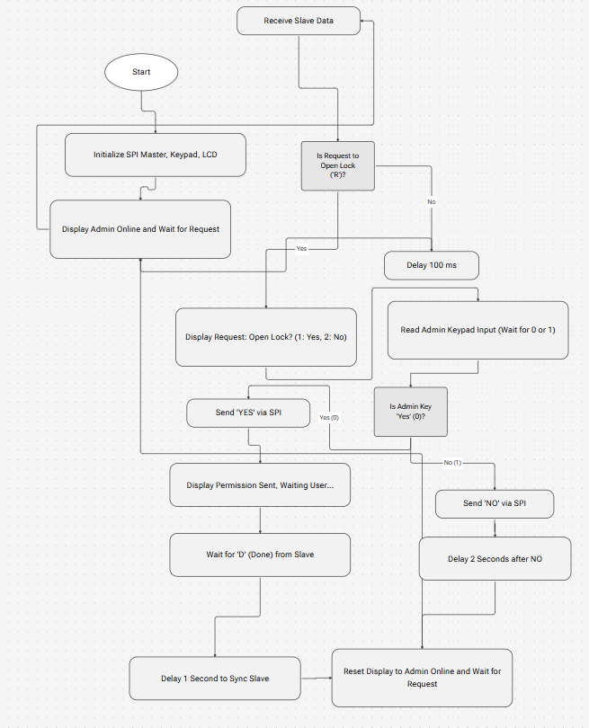

Slave Flowchart
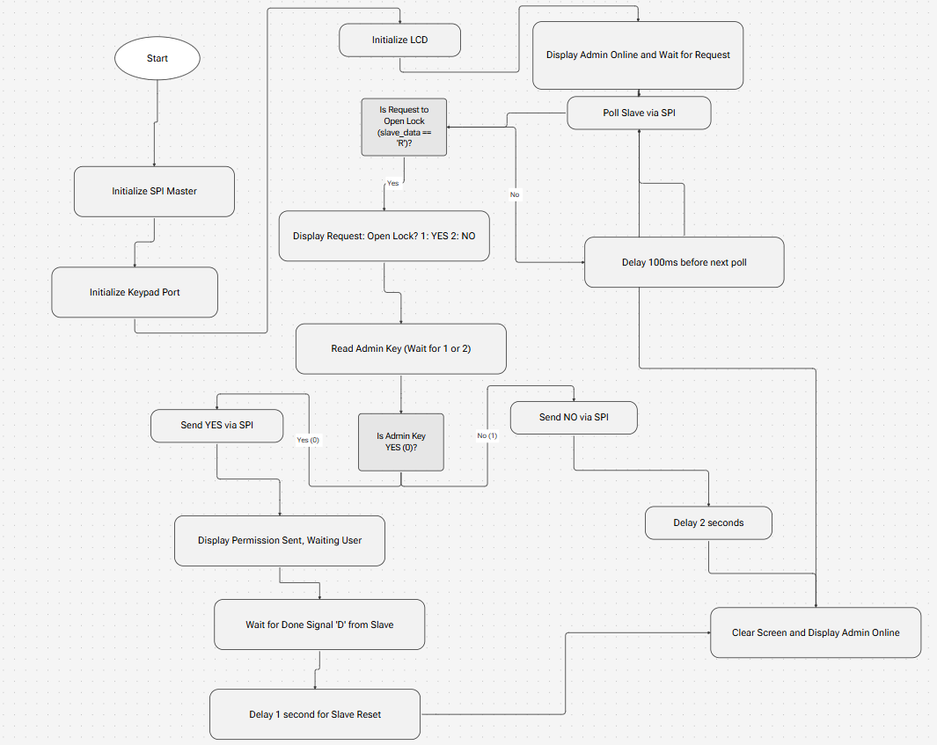
References:-
1. NXP MC9S12DG256 Device User Guide
- Link: NXP MC9S12DG256 Datasheet (PDF) (Note: NXP often archives older docs; AllDatasheet is a reliable mirror for this legacy chip).
2. Wytec Dragon12-Plus2 Reference Manual
- Link: Dragon12-Plus Manual (PDF) (Hosted by York University)
3. Motorola SPI Block Guide V03.06
- Link: SPI Block Guide V03.06 (PDF) (Datasheet Archive)
4. Textbook: The HCS12 / 9S12: An Introduction to Software and Hardware Interfacing
- Link: Google Books Record
5. Micrium uC/LCD Driver (Source of lcd.c)
- Link: Micrium uC/OS-II Book Info
6. Wytec Board Support Package (BSP)
7. Textbook Manual from the lab5 on eclass.

